Recent CIL Allocations in the Somerset West & Taunton Area

Bishops Hull
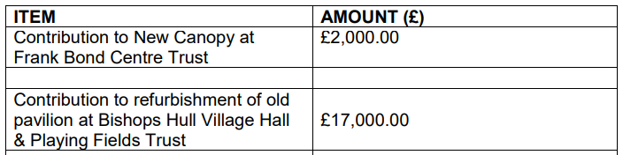
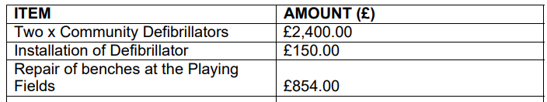
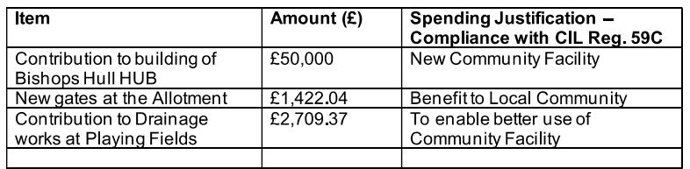
Bishops Lydeard

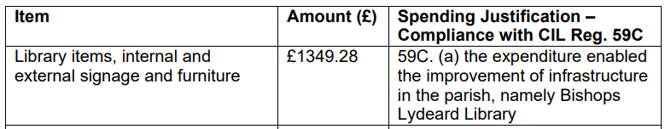
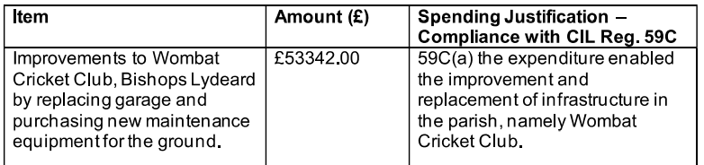
Burrowbridge
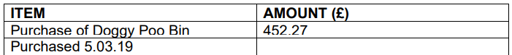
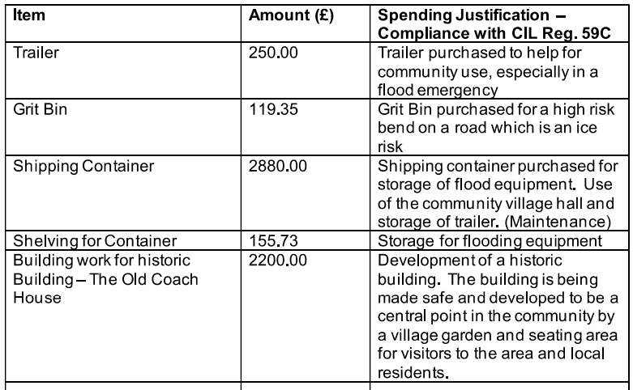

Cheddon Fitzpaine

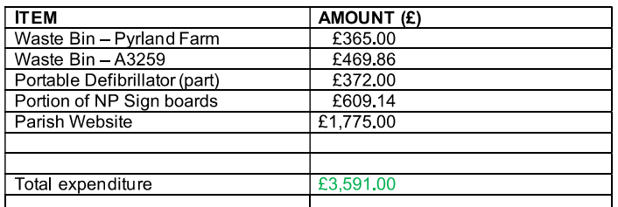
Churchstanton
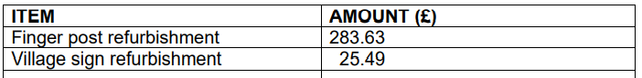

Comeytrowe
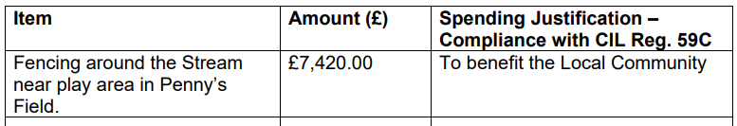
Cotford St Luke
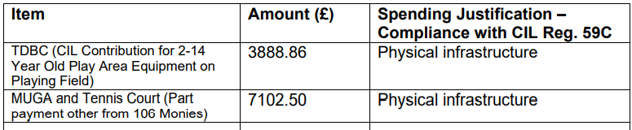
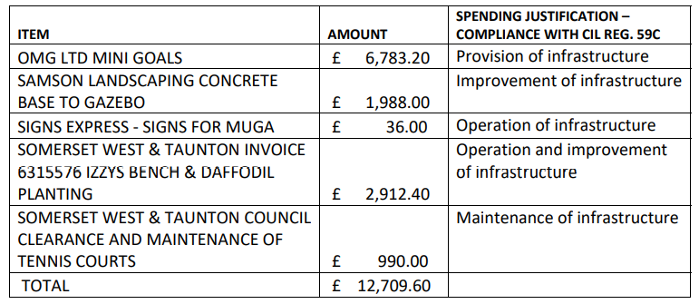
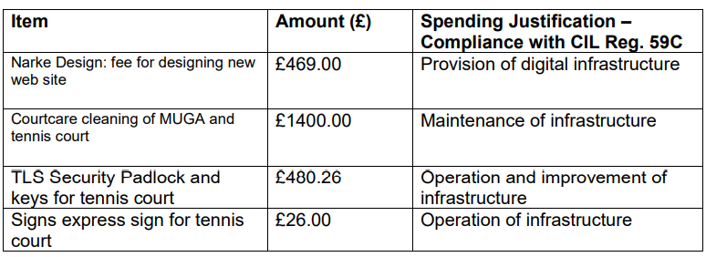
Creech St Michael
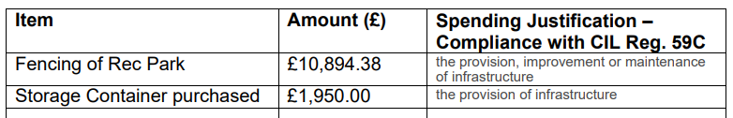
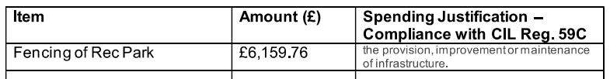
Langford Budville
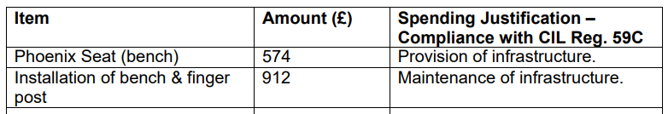
Lydeard St Lawrence
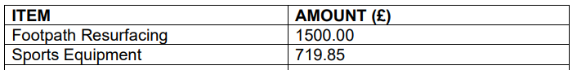
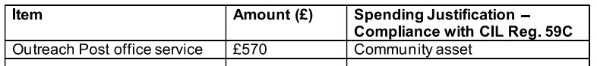
North Curry
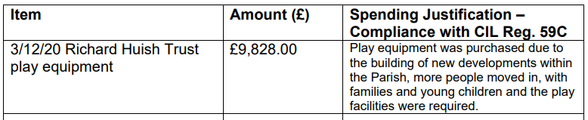
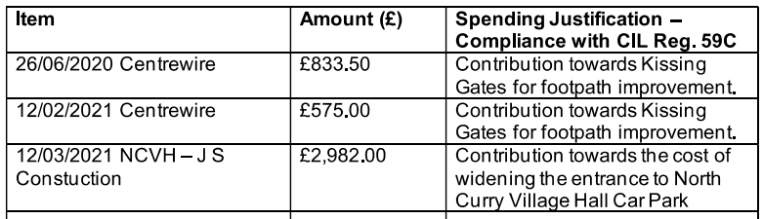
Nynehead
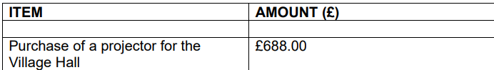
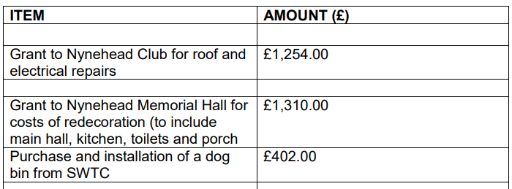
Oake
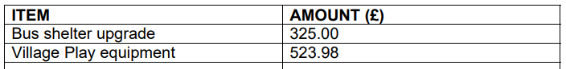
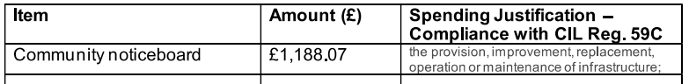
Otterford
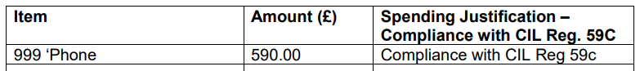
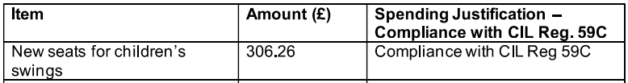

Pitminster
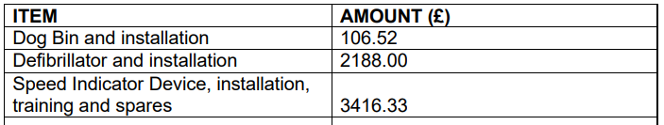
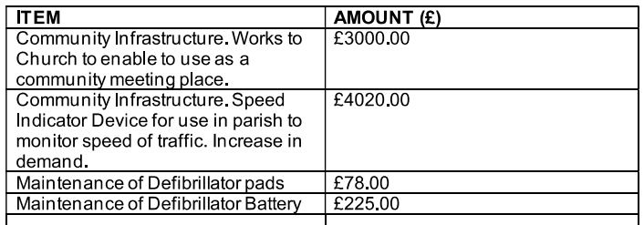
Staplegrove
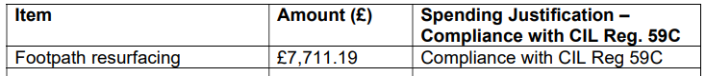
Stawley
Stoke St Mary
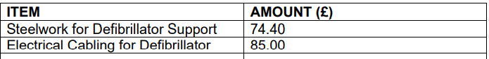
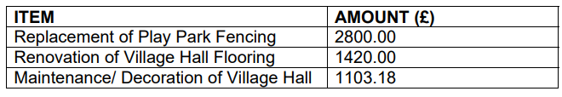

Trull
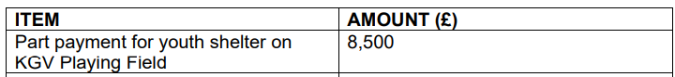
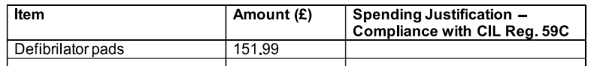
West Buckland
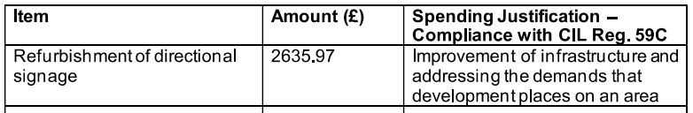

Wellington Without
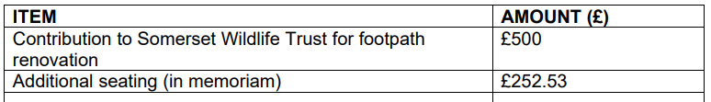
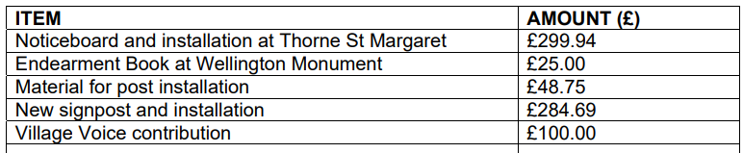
West Bagborough
West Monkton
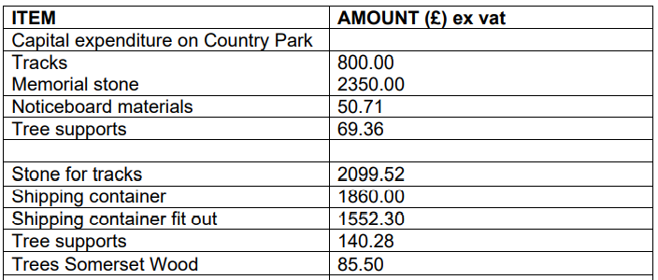
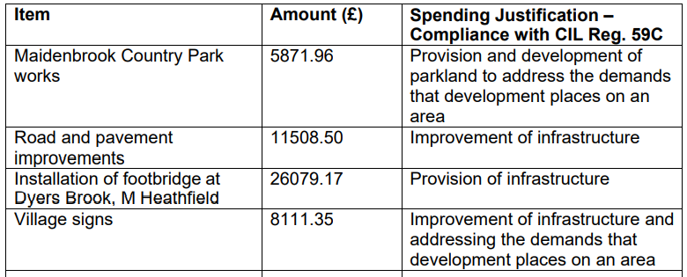
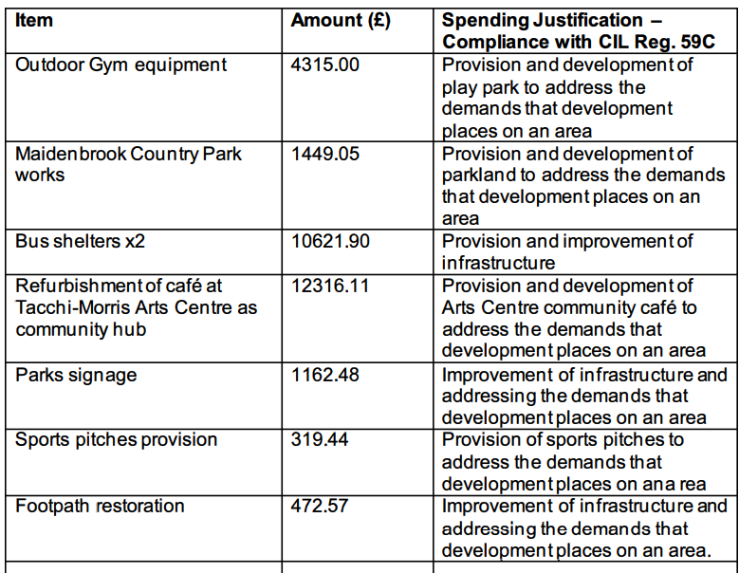

Wiveliscombe
